# **Sprint 1 Plan Thru-Hiker** Sprint completion date: TBD Revision 1, 4/10/24

### **Goal:**

Ability to select a trail, and a home screen featuring an interactable map of the trail, and ability to track users progress from daily steps.

### **Tasks:**

* + **High Priority - User Story - 1.1 [8 points]**

As a user, I want to be able to select a thru-hike and set a time goal from an explore page so that I can plan my hike accordingly. 8 Points

* + **Medium Priority - User Story - 1.2 [5 points]**

As a user, I want to see a map of my progress on the selected route so that I know how much of the trail I have completed. 5 points

* + **Low Priority - User Story - 1.3 [3 points]**

As a user, I want an interface to view statistics such as how far I've walked in however long I’ve been walking the route. 3 points

Task 1: Ability to select trail (5 hours)

Task 2: Interactive map of progress (20 hours)

* Map that has trail line/layer and a dot that shows progress

Task 3: Points of interest/landmarks (15 hours)

### **Roles:**

Gavin: Backend Lead

Kai: Front End Lead

Brandon: Developer/Scrum Master

Ayman: Developer

Taylor: Developer

### **Task Assignment:**

Gavin: User story/Task 3, User story/Task 2

Kai: User story/Task 1, User story/Task 2

Brandon: User story/Task 2

Ayman: User story/Task 2

Taylor: User story/Task 2

### **Initial burndown:**

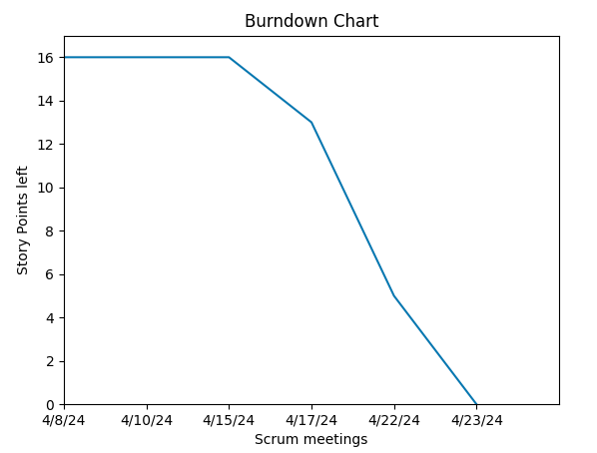

**Initial scrum board:**

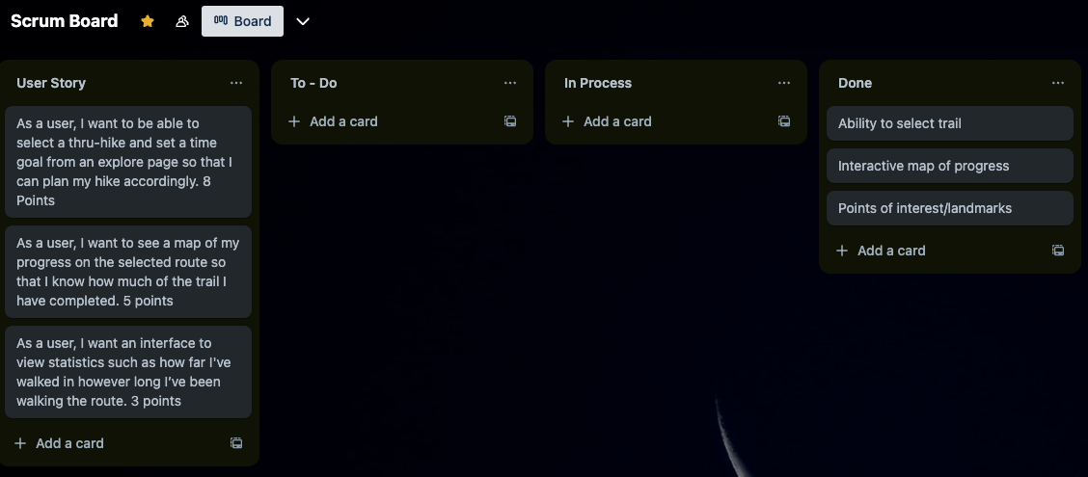

**Scrum time:**

Monday, Wednesday, Friday 12-1pm. TA meeting on Friday 12-1pm.